How to put web app code on Azure Web app :

1. Once the web app is created , go to deployment credentials options :

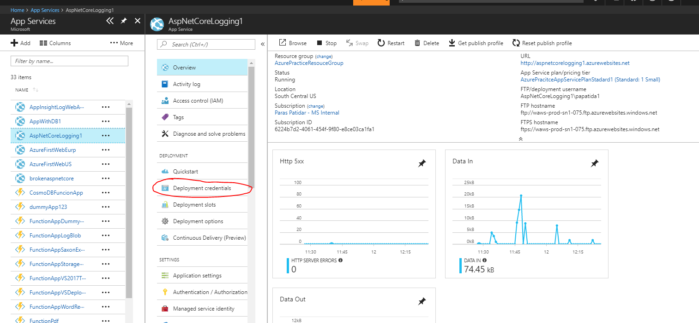

1. Set the user id and password for FTP deploye :

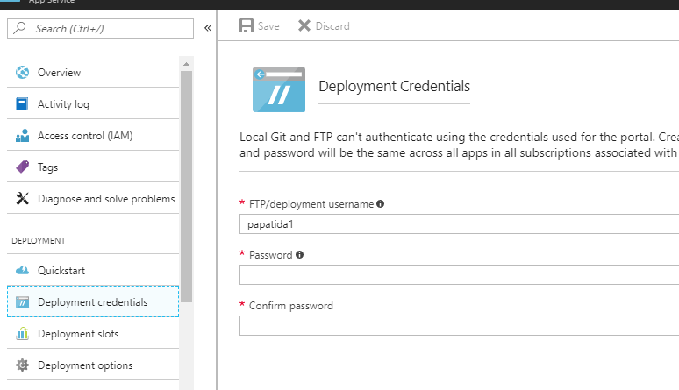

1. Go to overview option of that Web app :

Note the User name , which is like <webappname>\<username>

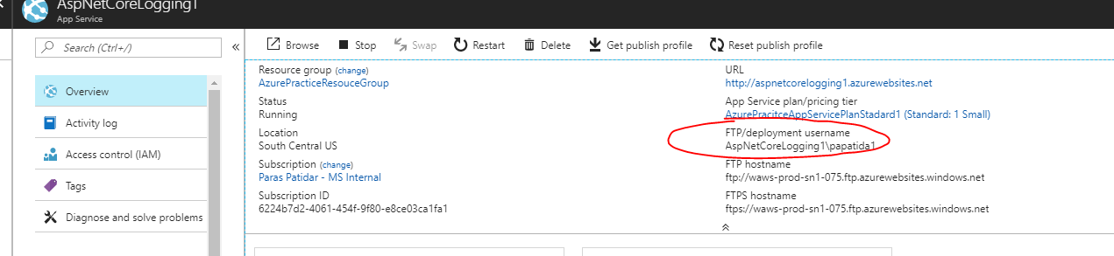

1. Note the FTP deployment address :

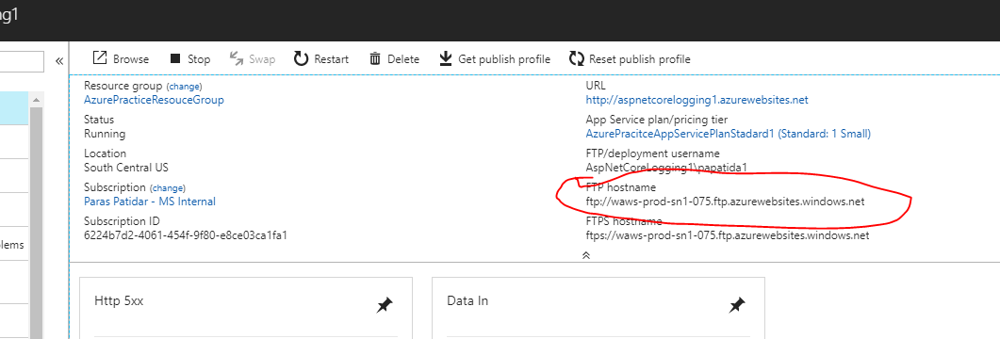

1. Now to connect it via network folder in windows 7 (little different steps for windows 10 but wizard is same) , we are going to see the “network location” method and not “map network drive” method :

The network location will take the server address as : <ftp://waws-prod-db3-081.ftp.azurewebsites.windows.net>

While map network drive will take it as : [\\waws-prod-db3-081.ftp.azurewebsites.windows.net](file:///\\waws-prod-db3-081.ftp.azurewebsites.windows.net)

Refer here for both version to reach the network folder : <https://support.microsoft.com/en-in/help/4026635/windows-map-a-network-drive>

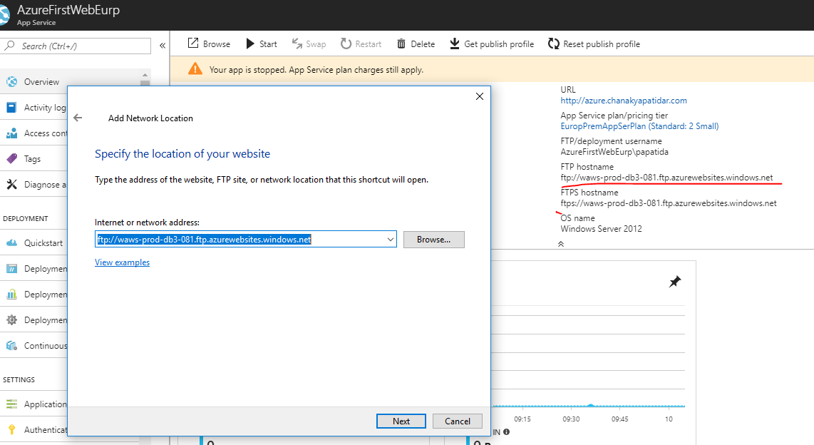

1. Disable the anonymous logging and put the FTP Username :

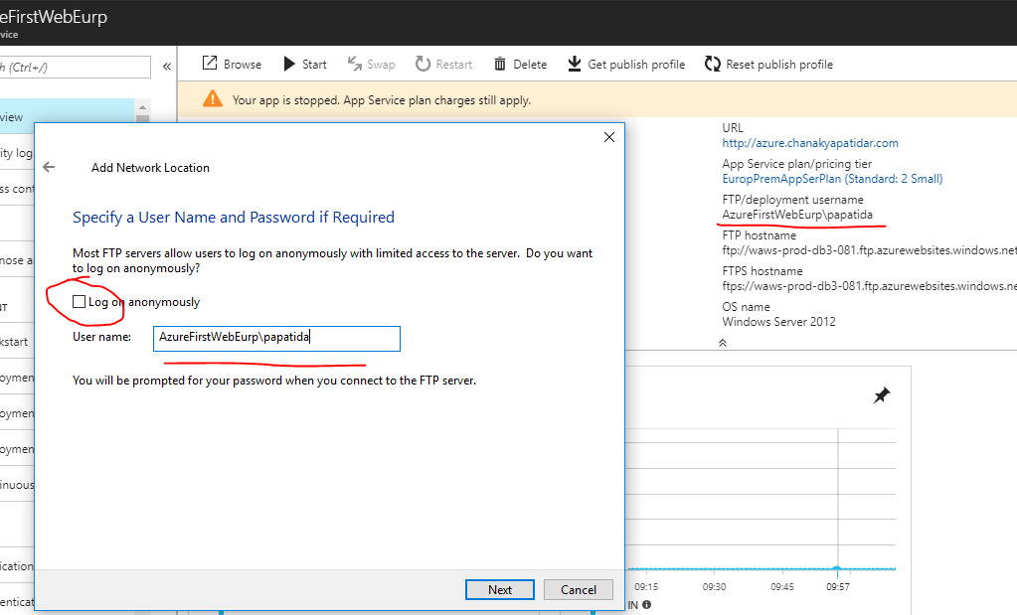

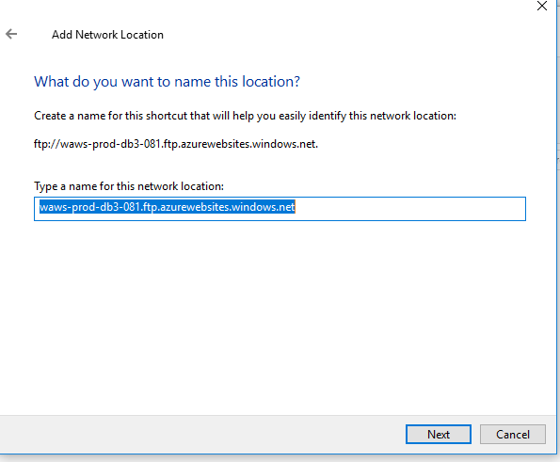

1. Now when this drive gets open , put the password which we set in step 2 on portal:

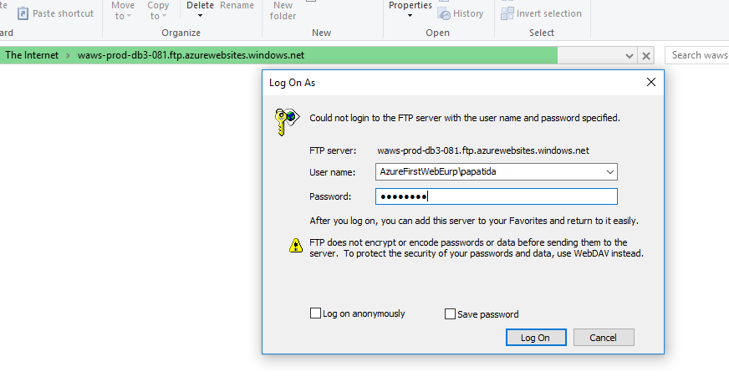

1. It should open the folder :

